**SEQUENCE DIAGRAM**

**1.During Presentation Development:**

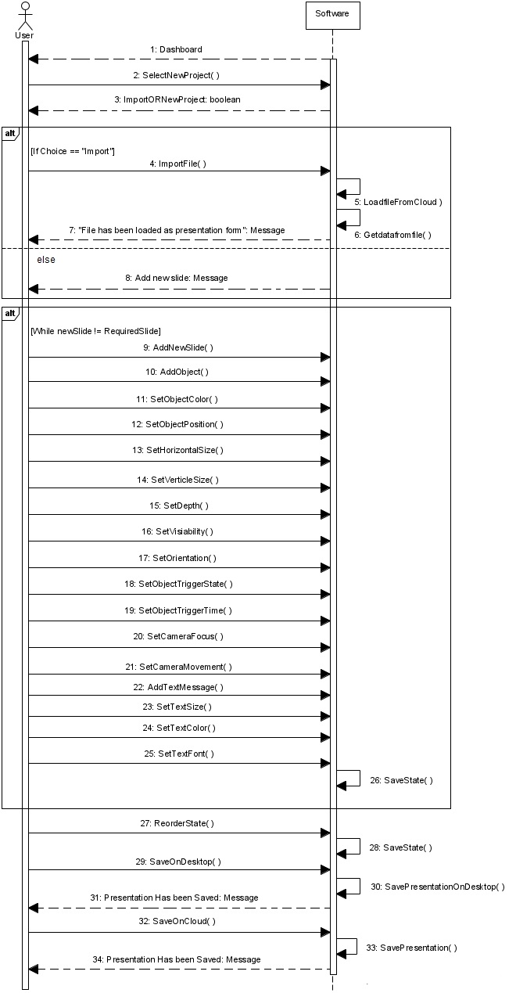

**2.During Edit Phase**

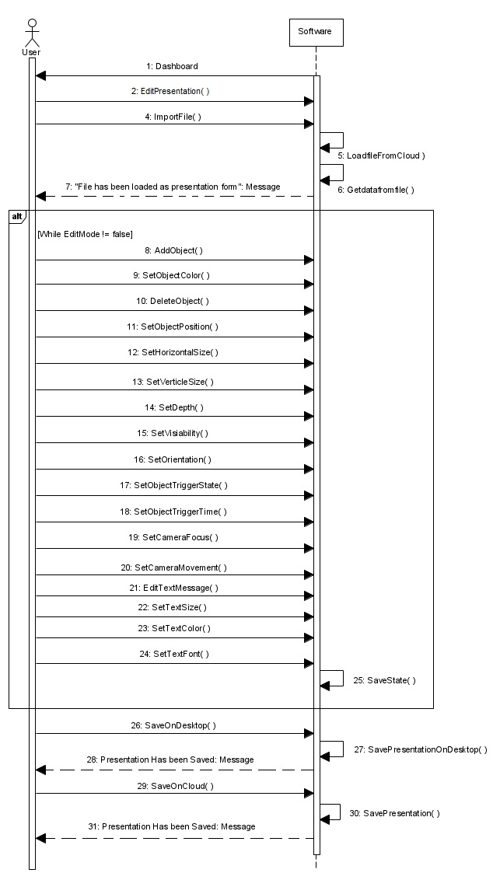

**3.During Presentation Phase**

